http://publicsource.org/sites/default/files/project/logo/under-the-keystone-logo-web.png

- Objects are described by _______________
- Parts work ________ as a ______________.

- Objects can change _______/________
- Mater cannot be ________ or __________
- Matter is ________________.
- Sort & _________
- Evidence
- ___________, charts and _____________
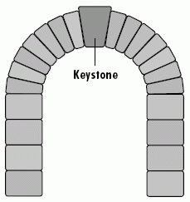
- Stability of structure & function are ________________.
- Function = _________
- Structure designed for _______________.
- Observable _______________
- Explain ________
- Used for __________________

- Change can occur slow or ___________.
- Measured in ___________ over time.
- Small changes can = _______ changes elsewhere.
- Some changes are __________
- Comparisons
- _________ for _______________
- Allows for __________ study

- Big Ideas that:
- __________ science
- help us understand _________, science, & engineering.

7 CCC’s

