Science Fair Information

Dear Students and Parents:

It’s time to start the first project of the year for 8th grade honors students, the science fair. Enclosed is a schedule outlining tentative due dates and important information regarding your child’s project. Do not throw this packet away, as your student will not get another copy. Ample time has been scheduled and work should be spread out, so that the student can complete the work at a comfortable pace. This is a major project and will represent a significant portion of your child’s grade for first, second and third quarters. The primary objective of this project is to have students approach a problem scientifically. This includes:
1. Asking questions and forming hypotheses.
2. Creating experiments to test those hypotheses.
3. Organizing data and drawing conclusions.
4. Writing about scientific research.

The project must be experimental in nature as opposed to research oriented. In other words, students must do a test, survey, or experiment to determine the answer to their question vs. just looking it up in a book or on the Internet. Students are encouraged to pick topics that they are genuinely interested in, since they will be working on this project for the next few months. Topics must also be “original” something students do not already know. Students will work individually, NO TEAM PROJECTS.
Each project must include:
- Topic Approval: Each student will complete a topic approval form found on his or her Google Classroom. The students must complete this topic approval BEFORE September 30th. Mrs. Sandoval will then either approve or deny the science fair project. Any projects denied will need to be resubmitted using a new science fair topic and resources. This portion of the science fair is to be completed at home. (50 pts.)
- Research Plan: Student will write a research plan before beginning their project. This paper will be completed using Google classroom and the students will be given time in class. (50 pts.)
- Registration Paperwork: This will vary from student to student depending on the type of project. Students who do projects involving microbes, animals, people, hazardous materials and/or devices will be required to complete additional paperwork before beginning their project.
- Display: This includes taking pictures or making sketches of the experimental process, gathering materials, building, and setting up the display for presentation and judging. (100 pts.)

Project guidelines state that the student must do all of the work. However, teachers, parents, etc. may provide assistance. It is very difficult to work alone without the exchange of ideas and in some cases experiments rely on more than one person for completion. So we encourage you to brainstorm with your child about different ideas and possible topics that your child may want to pursue. Using my website www.sandovalscience.weebly.com password: science21 will give you links to various websites that are a great place to start thinking about projects. Please take some time to review these with your student in order to help them generate topic ideas. Projects should NOT be copied from the Internet!

Our school science fair is the first step in the process. Our school will have approximately 150 participants; of those only 40 will move to the regional fair at SUU in the spring. Because of the nature of this fair, if a student is chosen to move forward they need to COMMIT to attending. The regional fair does require a fee for participation; the school will cover this fee. However, if a student commits and backs out after they are registered, they will pay that fee back to the school plus $5 for the late fee to register another student.

I am looking forward to working with you to make this a valuable learning experience for your child. I appreciate your support on this important project. Please contact Mrs. Sandoval for any questions or concerns.

Sincerely,

Mrs. Sandoval cassy.sandoval@ironmail.org

Monthly Calendar Project Guide

The only exact deadlines are those for the research plan and the actual project. This calendar is provided to help you gauge your work so that you are not suddenly trying to complete a 3-month project in 3 days. Pace yourself and do your best work.

September
September should be used to come up with a question. Your science fair question is due September 30th. With your question you must submit three sources that you used to influence your project choice. These sources must be cited in APA format. Students who are doing this at home can use an online citation maker, such as Oslis Citation Maker, to ensure that those are done correctly. Additional citing information can be found at the back of this packet. The science department will go over these questions to make sure they are testable and decide if they require special paperwork. Your questions will be handed back early October with feedback. The students will complete this in Google Classroom at home. No class time will be given toward topic approval submissions.

October
This month we will work on research plans in class, and students should begin experimenting. However, a research plan must be done before experimentation begins. Plans consists of a question, hypothesis, data plan, (how will you show your work? Data tables, graphs, etc.) These will be done and turned in early October, graded and turned back to the students who will then have the opportunity to make corrections. Remember this whole portion is done in class.

Please keep in mind that if you are testing other subjects as part of your experiment (including humans as well as all animals with a vertebrae), if you are using dangerous or hazardous chemicals or devices, or if you are planning to work with germs (bacteria or viruses) your project will require special paperwork and a specialist to work with. So please do not start your project until it has been cleared with me, Mrs. Sandoval.

November
Work on your project. You should be experimenting and recording data.

December
Complete your science fair project and board.

January
Canyon View Middle School Science fair will be held January 20, 2017. The top forty students will move to the Southern Utah University Science and Engineering Fair, this fair will be held in March but the date has not yet been announced. Winning students will be required complete necessary paperwork for the regional fair.

GOOGLE CLASSROOM:
All 5th Period Honors students need to log into Google Classroom to complete the Topic Approval Form.
- Log into your gmail account.
- Top right corner click the boxes and click “Google Classroom”
- At the top click Add +
- Enter the code: pf8589
- Click “Join”
- You should then see our class and the Topic Approval Form.
- As more forms become available you will see these as well.

What does a good display board look like?

Choose a display board that is colorful, red, blue and green are good choices. If white is the only color available, dress it up with bright or bold colors to matte your information.

Your display board should be organized in a way that is easy to follow and understand. Organize your information like a newspaper so that your audience can read it from top to bottom and then left to right.

Use a large font size, at least 16 pt. or larger for your titles. Your can use slightly smaller font for sections that involve a lot of writing, or for captions on pictures. People should be able to read your board from across the room.

You must acknowledge where you obtained any pictures, data tables and graphs from, even if you created them or took the pictures yourself.

Example:
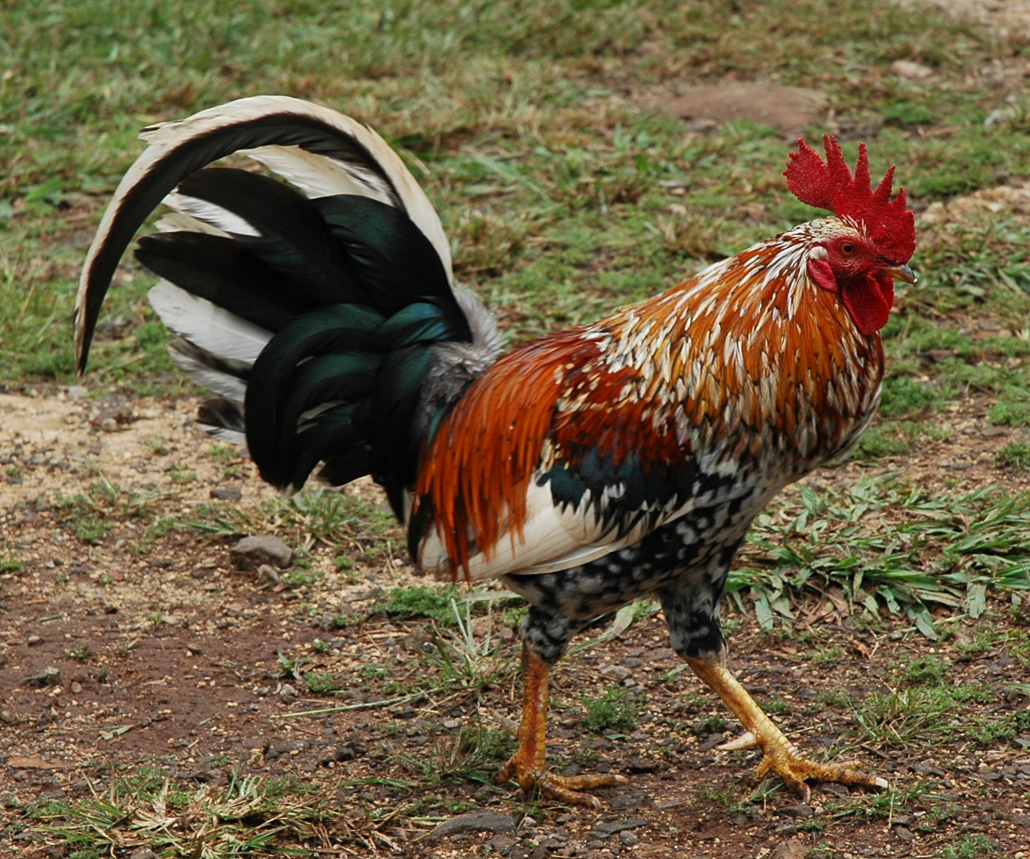
The rooster is the image you are using.

The APA citation should be found below the image so that people know where you got the image.
Rooster picture. (n.d.). Retrieved August 8, 2014,
from http://www.cristinaglez.com/rooster-picture/



